

UBER RISK MANAGEMENT

Jason Buitrago, Dylan Glass, Quijhanae Lee, Justin Printz



DECEMBER 14, 2020

**Table of Contents**

Project Team 2

**Executive Summary**2

**Background Information**5

Basic Information 5

Organizational Structure 6

Manufacturing Facilities 6

Product Lines 7

Essential Business Functions 7

**Stakeholder Analysis**8

**Project Scope Statements**9

**Risk Analysis**10

Qualitative Analysis 10

Bowtie Diagram 11

Customer/Driver error 11

Social Engineering 11

User Data 12

Fault Tree 12

Risk Influencing Factors (RIF) 13

Data Dossier 13

Barrier Analysis 14

**Accident scenario**14

IRPA/PLL 15

Event Tree Analysis 15

Event Tree Analysis Rerun 16

**Works cited**17

# Project Team

For our Risk Management project, our team which consists of Jason Buitrago, Dylan Glass, Quijhanae Lee, and Justin Printz, will be using Microsoft Team and GitHub for working on our project. This allows everybody to work on the project at the same time along with having easy access to contact each other. Our GitHub link can be found here which includes simulations along with diagrams, https://github.com/SRA311/Uber.

# Executive Summary

Uber, which is a private company, is based in San Francisco, California. Their 5 major U.S. Offices, located in Seattle, San Francisco, Chicago, New York, and Pittsburgh. There are 17 major International Offices, located in Toronto, Mexico City, Bogota, São Paulo, Santiago, London, Amsterdam, Paris, Cairo, Dubai, Gurgaon, Hyderabad, Bangalore, Manila, Singapore, Sydney, and Johannesburg. Like other taxi services, Uber is a service that provides people with inexpensive rides allowing it to be convenient for both the driver and the rider. As of 2018, Uber has employed over 22,000 people and is operating in over 63 countries with around 700+ cities worldwide. Uber is constantly growing their business by adding new branches to their services, these can include UberX, Uber Pool, Uber Comfort, Uber Green, Uber Black, Bikes, Uber Scooter, and more.

Uber is the modern-day taxi service. For this, Uber must ensure that they are providing the best services for its riders and drivers. It is important to provide top-notch services for riders and drivers because they make up a decent proportion of the company. For example, Uber provides riders with an estimated time of arrival upon request, notification when the driver has arrived at the pick-up location, specific vehicle assistance, and the ability to request rides 24/7. The services provided for Uber drivers are a safe environment-- in terms of providing information about riders(vice versa), automatically charging riders once they’ve reached their destination, and verify riders before entering the car(face recognition via photo). Some of the major security challenges that Uber can face could include but are not limited to hacking in the mobile application or website, customers canceling the ride midway (the customer gets a free ride; the driver does not get paid), and more.

For the major assets of Uber, we will be using the SHEL model which can be shown in the diagram below:

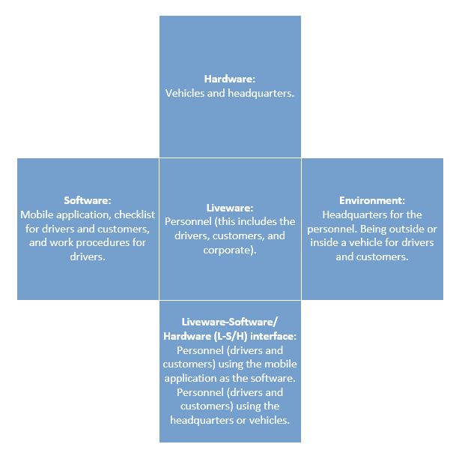

For our risk management model, we are going to use the NIST model. The way that we followed this framework in our analysis is by first identifying the organization (Tier 1), in this case, Uber. Then we will identify the mission/business process (Tier 2) of the organization, in this case by purchasing a ride through the application and then receiving the ride from the driver. Then we will identify the information system (Tier 3) of the organization, in this case, it is wherever the driver submits the request and the drop-off location they want to go to. This can be shown in the model below:

Level1:

Organization

Level 2:

Mission / Business Process

Level 3:

Information System

The benefits our project can bring to the organization can include security flaws that we found when going in-depth in research, a potential decrease in the value of assets for stakeholders, possible internal and external problems, and more. The possible constraints for our analysis can include not having the information of exact numbers for the assets that could affect the stakeholders, legal issues that could occur, budget issues regarding the company, and more.

# Background Information

## Basic Information

Uber Technologies, Inc formerly UberCab is similar to other taxi services, but users can order a ride through the Uber app on their phone. Uber is in the transportation industry. Some of the senior management of the company includes.

* Dara Khosrowshashi – Chief Executive Officer
* Nelson Chai - Chief Financial Officer
* Tony West - Chief Legal Officer
* Nikki Krishnamurthy - Chief People Officer
* Andrew Macdonald - Senior Vice President, Mobility & Business Operations
* Sundeep Jain - Vice President, Product
* Jill Hazelbaker - Senior Vice President, Marketing and Public Affairs
* Eric Meyhofer - Head of Advanced Technologies Group
* Bo Young Lee – Chief of Diversity and Inclusion Officer

Uber currently has over 22,00 employees worldwide. Their global headquarters is located in San Francisco, California. There are 5 major U.S. Offices and 17 international offices which can be seen below on the map.

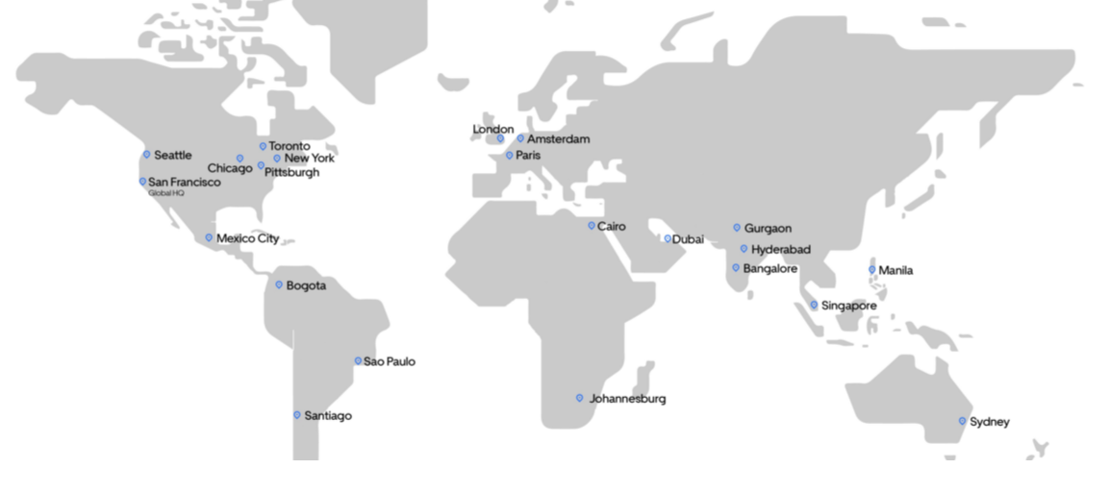

©www.uber.com

## 

## Organizational Structure

The organizational structure of Uber can be seen in the chart below.

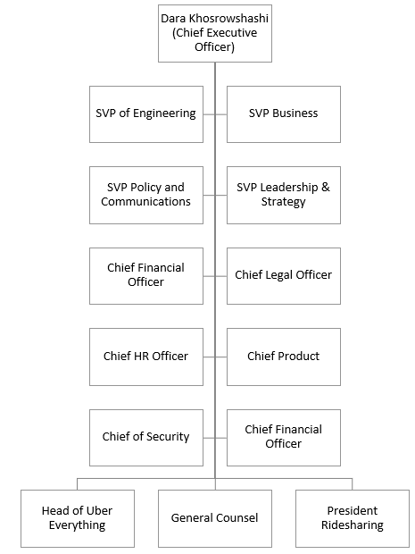

## Manufacturing Facilities

Uber has manufacturing facilities located all across the world in many different regions which include the following cities.

* Asia: Bangalore, Gurgaon, Hyderabad, Manila, Melbourne, Singapore, and Tokyo
* Australia: Sydney
* Europe: Aarhus, Amsterdam, Limerick, London, Madrid, and Paris
* Latin America: Bogota, Buenos Aires, Mexico City, Santiago, and Sao Paulo
* Middle East and Africa: Cairo, Dubai, Johannesburg, and Nairobi
* U.S & Canada: Austin, Chicago, LA & Santa Monica, NY, Phoenix, Pittsburgh, San Francisco Bay, Seattle, Washington D.C and Toronto

## Product Lines

Some of the important product lines for Uber include UberX, Uber Pool, Uber Comfort, Uber Green, Uber Black, Uber Scooter, Uber Bikes, UberXL, Uber Transit, Uber WAV, Uber Lux, Uber Black SUV, Uber Taxi, Uber Flash, Uber Auto, and Uber Air.

Out of the options that were listed above, 3 of the more popular ones include UberX, Uber Pool, and Uber Comfort. UberX is the standard service that allows up to 4 passengers making it cheap and affordable for most people. This option can be used for yourself only, or others along with you. Uber Pool is the cheaper version of the standard service, sharing the ride with other passengers. This option can be used as a joint ride service, allowing up to a minimum of 2 requested seats allowing room for others sharing the ride. The last service is Uber Comfort, which is like the standard service but instead has newer cars with extra legroom. This option can also be used for yourself only, or with other passengers.

## Essential Business Functions

Uber's mission states, “We ignite opportunity by setting the world in motion.” Uber provides the public with safe transportation, cheaper than most other companies in the same business, along with making getting a ride fast and reliable as there are users all around the world using the application. Uber has many essential business functions to keep running their business, which can include:

* Corporate espionage
  + Hacking, leaking, data breaches, trespassing
* Software
  + Computer & mobile functionality
* Stocks
  + Value, growth, exchanges
* Physical Safety
  + Drivers & customers
* Lawsuits
* Mobile application functions
* Website functions
* Review and ratings
* Investors
  + Stakeholders
* Financing
* Customer Service
* Information Technology
  + Cybersecurity, cloud, privacy
* Research and Development
  + Idea generation, concepts, commercialization, screening, product development

The business functions listed above are vital to Uber and the success of the company. This is because each of the business functions helps with the success of the business in some way shape or form.

With the success of Uber, we concluded that the three business functions we are going to be focusing on will include Corporate espionage, software, and stocks. This will be visualized on a data table with flowcharts included:

|  |  |  |
| --- | --- | --- |
| **Corporate Espionage**  **Flowchart** | **Software Flowchart** | **Stocks Flowchart** |
|  |  |  |

# 

# Stakeholder Analysis

When it comes to a stakeholder, they are interested in seeing the company succeed in profits as it will also increase the amount of money they are gaining. By presenting this risk assessment, it could show the possible stakeholders that Uber watches over the financial part of the business, along with the security and safety of others. When it comes to the actual stakeholders themselves, they are all affected by the changes that Uber makes. By making changes that better the company, could potentially increase the profits that the business gains. Such gains also affect those who invested in stocks and are involved financially with the company.

In our stakeholder analysis below, it shows which stakeholder holds the most power and over the company as well as their importance to Uber. We found that the most important stakeholders are Uber’s CEO Dara Khosrowshahi, the riders, and the drivers. Without these key stakeholders, Uber would not be able to function as they should. The CEO is the most important because he is the face of the company and he is responsible for updating the stakeholders about what is going on inside of the company.

Riders and drivers are both considered to be dependent. They do not hold a lot of power, but their concerns are very important to Uber. This is because they are the people that are using the service every day so if something needs to be done, they can express their concerns to the company. The riders and drivers are the main focus of Uber and they need to act on their best behalf to satisfy them.

Investors and employees are also some of the important stakeholders. Without the employees that invest in the company and the other investors, the company would not be able to function. So, it is very important to keep them in mind because they have power and can get things changed. Maintaining a good relationship with the investors and employees is very important for Uber to succeed.

The government also plays a big role in stakeholder analysis. They are considered to be dangerous because although Uber may not be thinking about them, they still have power. Although the government is not initially thought of as being an important stakeholder Uber operates in a lot of different countries and must take the different government regulations into mind.

Lastly, mobile operating systems providers have a role in the stakeholder analysis. They are considered to be discretionary because they are legitimate but have no power or urgency. They provide users with the Uber app which is where Uber must be used by its customers. They do not need much attention; this is just a place for the user to access the app. Attention is only needed for the mobile operating systems when updates for the app need to be sent out.

|  |  |  |
| --- | --- | --- |
| Possible Stakeholder | Type of Stakeholder | Importance (1-4) |
| Dara Khosrowshahi | Definitive | 4 |
| Riders | Dependent | 3 |
| Drivers | Dependent | 3 |
| Investors | Dominant | 2 |
| Government | Dangerous | 2 |
| Employees | Dominant | 2 |
| Mobile operating systems providers | Discretionary | 1 |

# 

# Project Scope Statements

The business functions that are important to Uber are corporate espionage, software, and stocks. Corporate espionage is one of the most important functions, it makes sure that there are no breaches, leaks, or any information stolen. The software for Uber is always being improved, making it easier to use for the customer. Stocks help Uber gain more income from investors, allowing them to invest it into themselves, making their service better. This can be seen from the data table shown below:

|  |  |  |
| --- | --- | --- |
| Functions | Assets | Input and Output |
| Corporate espionage | Employees, stakeholders, customers | Input: Someone spies on the company  Output: Company gets information stolen, as a result, have a bad reputation |
| Software | Data, employees, end-users, application | Input: Coders work on the backend  Output: Better usability for the users |
| Stocks | Financial, stakeholders | Input: Someone invests in Uber  Output: Stock goes up, Uber gets more to invest in themselves |

If there is a blind spot or a weak point in the software that can lead to espionage, and private customer or company information can potentially be leaked. If this happens there will be a public backlash and that will be reflected in the company stock. Investors will not trust Uber and they will pull out their shares. Causing Uber’s stock to fall and the company will lose money and trust. An incident like this would be category three in Rasmussen’s model.

# 

# Risk Analysis

## 

## Qualitative Analysis

Below is a chart for qualitative analysis, showing potential risks, hazards, and barriers.

|  |  |  |
| --- | --- | --- |
| **Risk** | **Potential Hazards** | **Barriers** |
| Customer/Driver error | Drivers could get in accidents; customers could get in the wrong cars | Description of vehicle,  name of customer and driver, driver safety training |
| Social Engineering | Phishing, corporate espionage, employee intrusion | Longer login passwords, 2fa, increased security |
| User Data | Data not properly encrypted, security systems out of date, espionage | Stronger encryption, employee monitoring of attacks, multiple firewalls |

## Bowtie Diagram

### Customer/Driver error

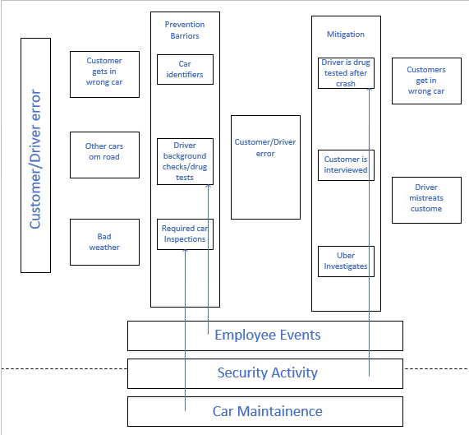

### Social Engineering

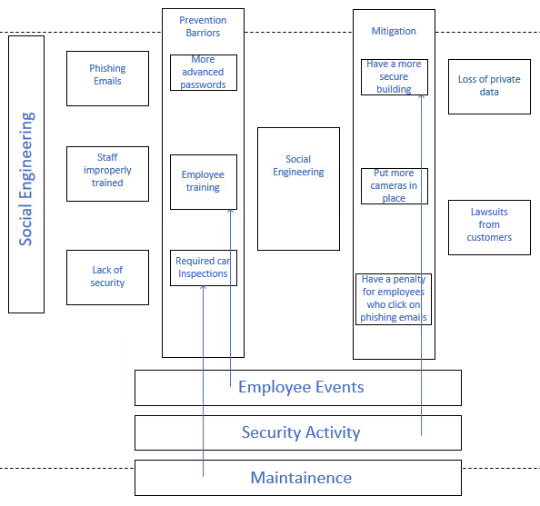

### User Data

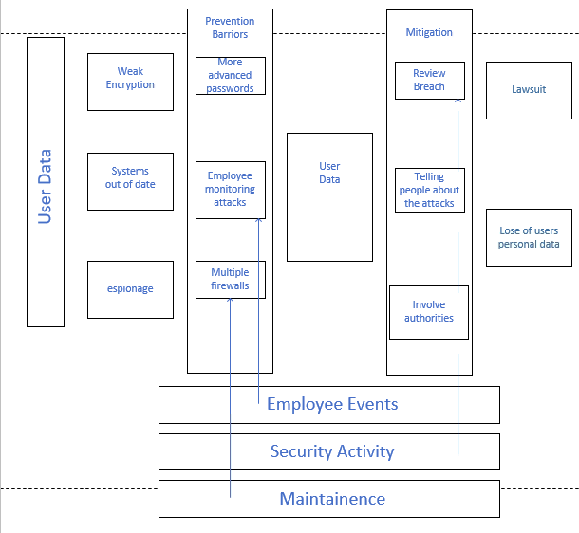

## Fault Tree

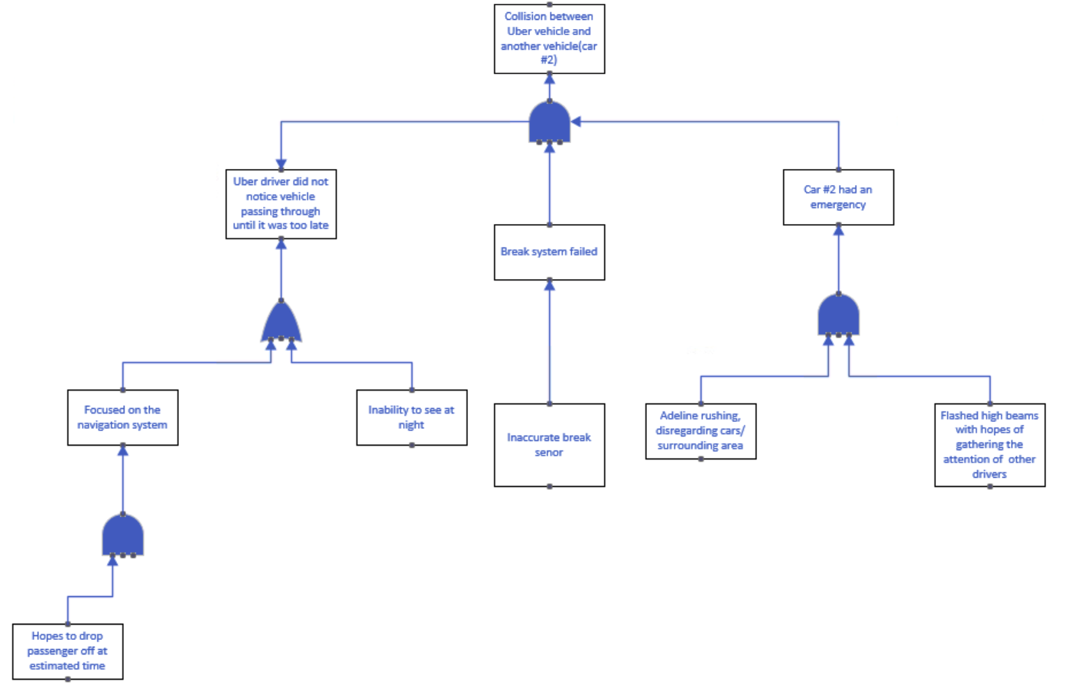

The incident demonstrated in the graph above is a collision. The event was caused by a driver who was in a rush to make it to the emergency room. As a result, he injured all persons that were inside of the vehicle.

## Risk Influencing Factors (RIF)

Risk influencing factors

1. Customer/Driver error
   1. Customers getting into the wrong car
   2. The driver gets into an accident
2. Social Engineering
   1. Weak passwords
   2. Phishing
   3. Corporate espionage
   4. Employee intrusion
3. User Data
   1. Data not properly encrypted
   2. security systems out of date

This can be seen in the diagram shown below:

|  |  |  |
| --- | --- | --- |
| Risk | Barriers | Rating |
| Customer/Driver error | Description of vehicle,  name of customer and driver, driver safety training | 4 - Doesn’t happen often but it can be resolved |
| Social Engineering | Longer login passwords, 2fa, increased security | 8 - If occurs, sensitive information is lost |
| User Data | Stronger encryption, employee monitoring of attacks, multiple firewalls | 10 - Account is compromised, a user should monitor personal accounts for possible malicious attacks |

## 

## Data Dossier

Below is the chart for the data dossier, describing Uber’s application and how a user’s account could be compromised, and how to prevent it from happening.

|  |  |  |  |  |
| --- | --- | --- | --- | --- |
| Component: | Description: | Failure Mode: | Testing and Maintenance: | Comments: |
| Uber's application | For customers to connect to Uber they must download the application and log in. After the customer connects their account to a debit/credit they can order rides. | Weak password.  Weak encryption.  Brute force attack. | Changing the encryption, telling users to add 2FA, uploading updates to the application | Increased security to reduce the risk.  With 2FA enabled, it makes it harder for hackers to get into. |

## Barrier Analysis

Below is a chart showing the barrier analysis for an Uber car accident. This includes the factors for pre-collision, collision, and post-collision. If one of the phases were to occur, there is a likely chance that the corresponding factors will take place.

|  |  |  |  |  |
| --- | --- | --- | --- | --- |
| Car Accident |  | Factors |  |  |
|  |  | Human | Equipment | Environment |
| **Phases** | **Pre-collision** | The car is driving fine and everyone is ok | All equipment is functioning properly | Driver is focused |
|  | **Collision** | Someone is hurt | The car is damaged might need work | Inclement weather |
|  | **Post-collision** | Someone dies | Car is total and Uber application is disabled | Damage from inclement weather |

# Accident Scenario

1. Drive gets distracted while on the job
2. Driver crashes into another vehicle
3. The customer is injured and is taken to hospital
4. Insurance and Uber covers the cost for the customer
5. Uber gets sued

### IRPA/PLL

0.0000428% of death caused by Uber (107/2.5 Million)

A = 50 / 200 = 25% (50 hrs per week / 200 hours per month)

IRPA (Death due to Uber accidents) = 0.0000428 * .25 = 0.0000107

PLL: 2,500,000 million * IPRA

2,500,000 * 0.0000107 = 26.75 fatalities

With the IPRA/PLL calculation shown above, there are around 26.75 fatalities per year.

### Event Tree Analysis

Below is our event tree analysis that shows the percentages of Uber drivers that get into accidents along with showing the percentages of deaths as a result of these accidents. We took into account if the driver was distracted, if there was inclement weather if there were injuries involved, and if there was a death involved due to the accident.

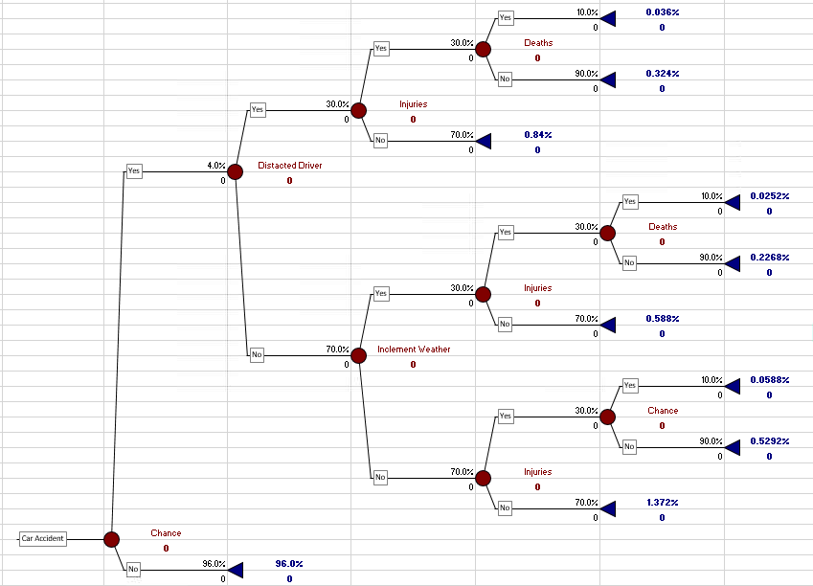

### Event Tree Analysis Rerun

When we reran the event tree analysis with the control barrier of watching safety training videos for the drivers the number of accidents and deaths decreased significantly. The number of deaths before this control was 0.036% for people who got in an accident while in an Uber. That percentage went down to 0.00000750% of deaths that occurred when in an accident with Uber.

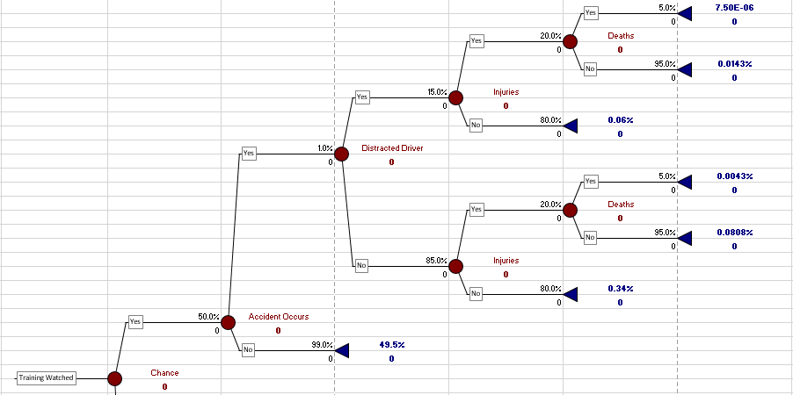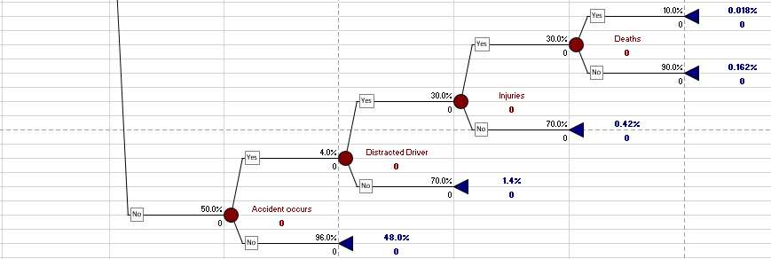

# 

# Works cited

*Earn Money by Driving or Get a Ride Now | Uber Netherlands*. (2014). Uber.

https://www.uber.com

*Just a moment... (n.d.). Craft. https://craft.co/uber*

Kiplinger, L. U. T. (2016, February 22). Kalamazoo shooting: A look at Uber background

checks. USA TODAY. https://eu.usatoday.com/story/money/2016/02/21/uber-puts-prospective-drivers-through-background-checks/80703630/

*Risk Assessment: Theory, Methods, and Applications*. (n.d.). O’Reilly Online Learning. https://www.oreilly.com/library/view/risk-assessment-theory/9780470637647/22_chapter12.html

*Safety*. (n.d.). Uber. https://www.uber.com/us/en/safety/